**Sprint 2 Personal Portfolio**

(Group 77- Group A)

(Mingze Dai – n9881093)

(EatChiliDaily)

**Artefact 1** – **HTML design** for advertisement and sign up page

Description about what the artefact is in general

HTML is the standard mark-up language for creating web pages and web applications. With Cascading Style Sheets (CSS) and JavaScript, it is the fundamental technology used to define the structure and content of a webpage. This artefact is designed webpage for user sign up process and customer accessible page (show the most popular cars to customers and social application contact us details)

Brief description of how it was used/contribution to the project

This sign up page design was used for company staff who wants to create an account to have access to the management system and they are required to input account name, password and confirmed password in the input text field. By clicking “sign up” button, all information user input will be sent and stored to the webserver. This page design has a “MUST” priority which means it is a core part of the project, the sign-up page is one of the basic main function overall.

Advertisement page is a page where provides customers the most popular cars recently and also give company’s contact details at the bottom of the website. Customers can view car details by clicking the image in the middle of the screen. This page meets the customers’ need and it’s a strong supporting page for the project.



Screen capture of where it’s used

Signup page:

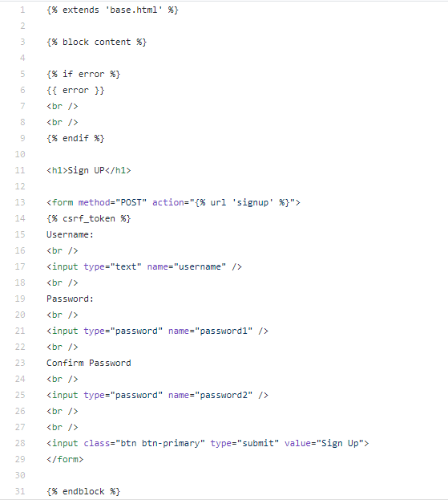

Advertisement page:

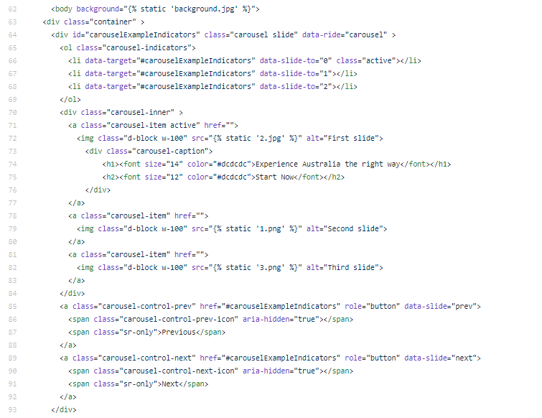

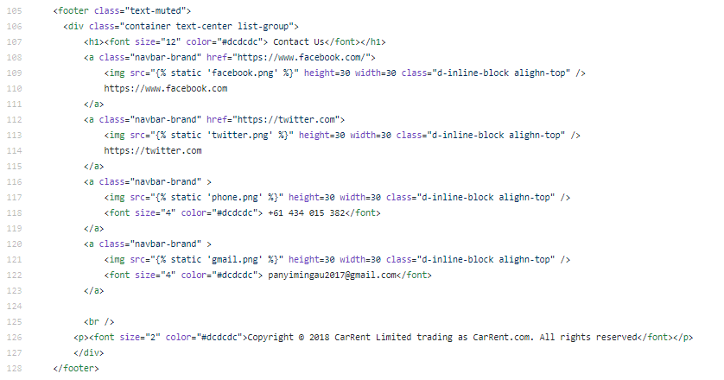

**Artefact 2** – **Test cases**

Description about what the artefact is in general

This artefact is test cases for User Story 5: Sign up, User Story 24: History Data Mange - Edit, User Story 27: Car description, User Story 29: Filtering - Customer accessible page, User Story 30: Filtering - History/Data manage. The purpose of this artefact is to test the functionally of webpage linked to above user stories according to acceptance criteria listed in user story which also including: Precondition, steps, test data, and post condition.

Brief description of how it was used/contribution to the project

The test cases were used to check the operational status, whether the actual web design meet the acceptance criteria or not by following the Precondition, steps, test data, and post condition form. For example, in CRC_TC_01, if customers input different password in “password” and “confirm password” input field, the web page will show up an error message and route back to this page to ask user for a retry. If every input information meets the requirement, the account information will be sent to the web server.

These test cases contribute to the project by quality screening and find out the existing and potential vulnerability or the features that does not meet the standard. However, it helps the development team make changes and upgrades which can improve the design quality and decrease bus or inadequacies. Thus, test cases help improving web page practicality stability and make it more functional.

Screen capture of where it’s used

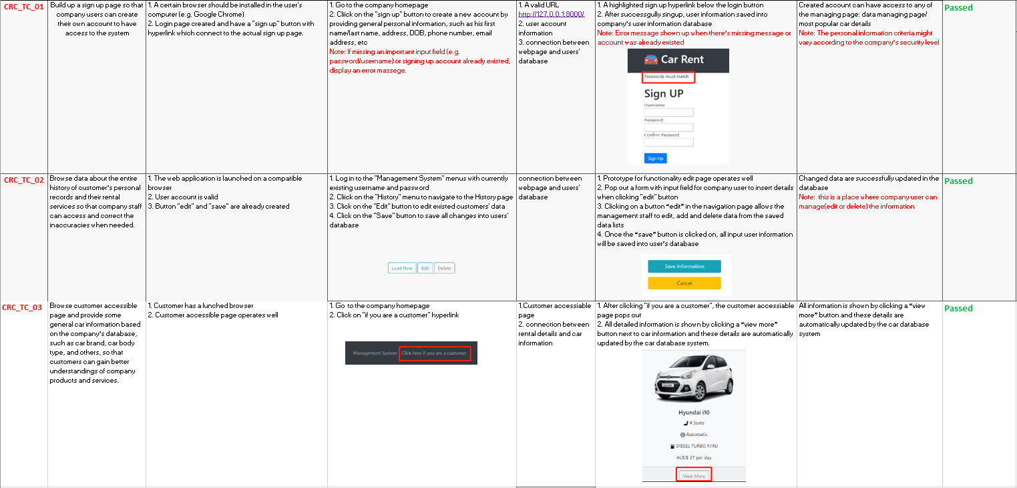

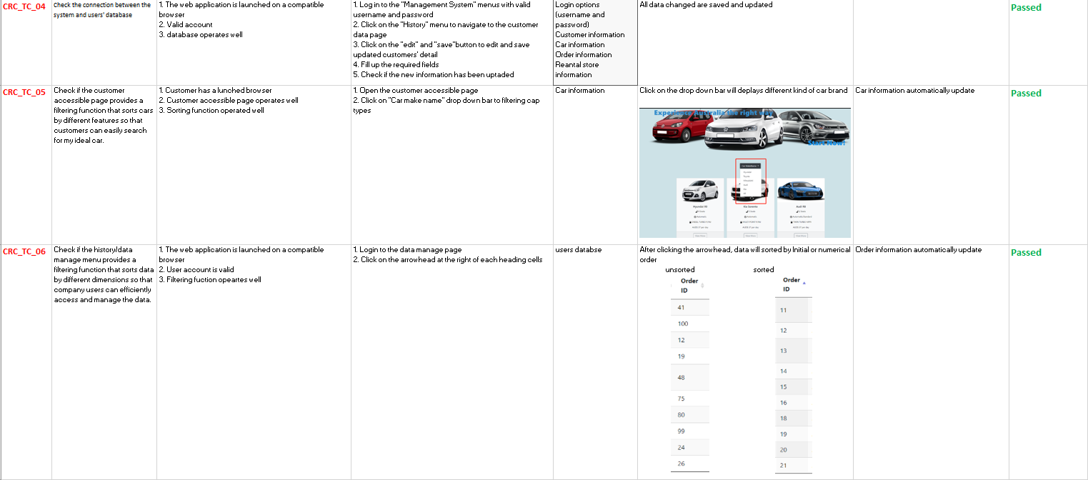

**Artefact 3** – **UI designs**

Description about what the artefact is in general

The user interface design for Story 11: Advertisement, Story 29: Filtering (Customer accessible page), Story 30: Sorting (History/Data manage) are design prototypes which give development team an overview about the overall design process and been set as a goal.

Brief description of how it was used/contribution to the project

The goal of UI designs is to make the user’s using experience better and more efficacy, UI designs are used to developed before actual web design which is not only operational but also usable and adaptable to changing user needs. For example, when company staff managing the user data, sounds of data may let them lose their focus, and will be hard to organize, but ui designs can consider this situation before it occurs and add some functions like sorting and filtering to ease the way how they manage data and orders. Each web page needs ui design as a prototype and template which gives development team the direction to moving forward, so it is a necessary and indispensable part of the project.

Screen capture of where it’s used

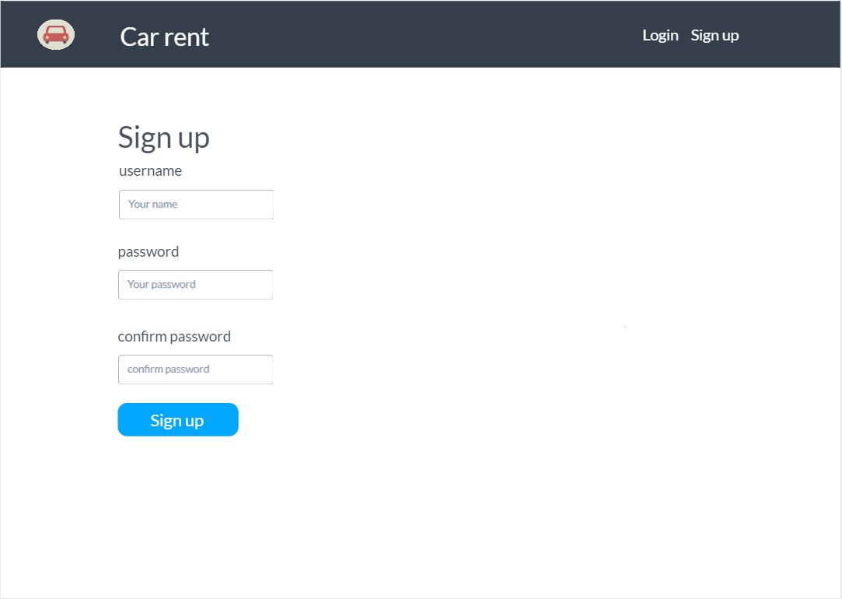

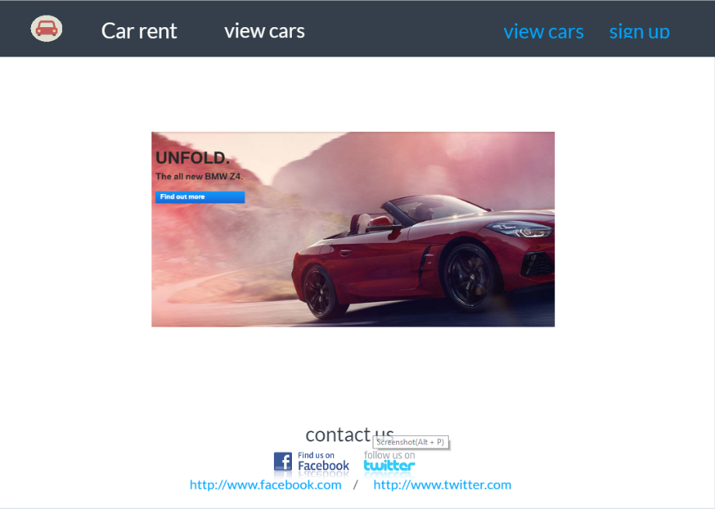

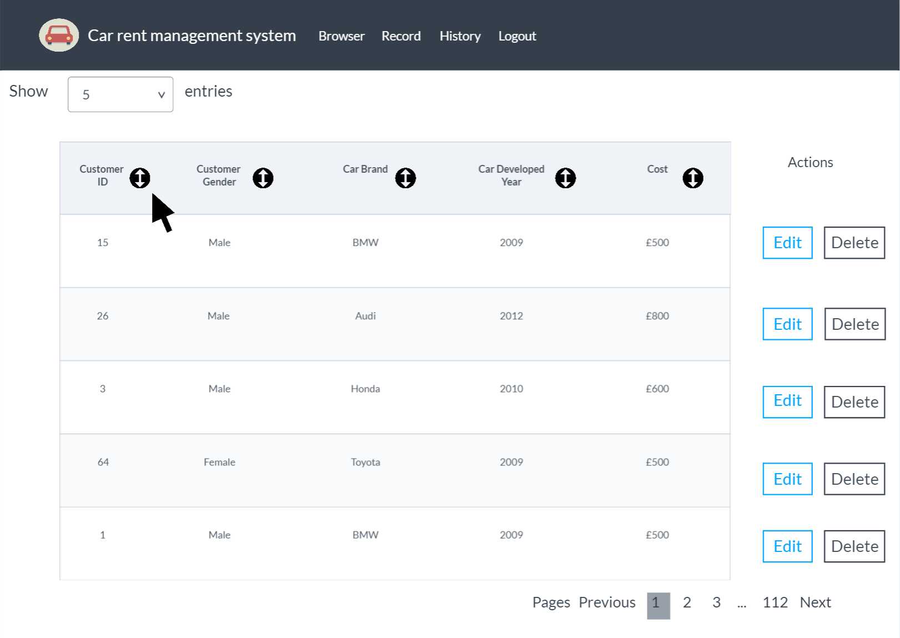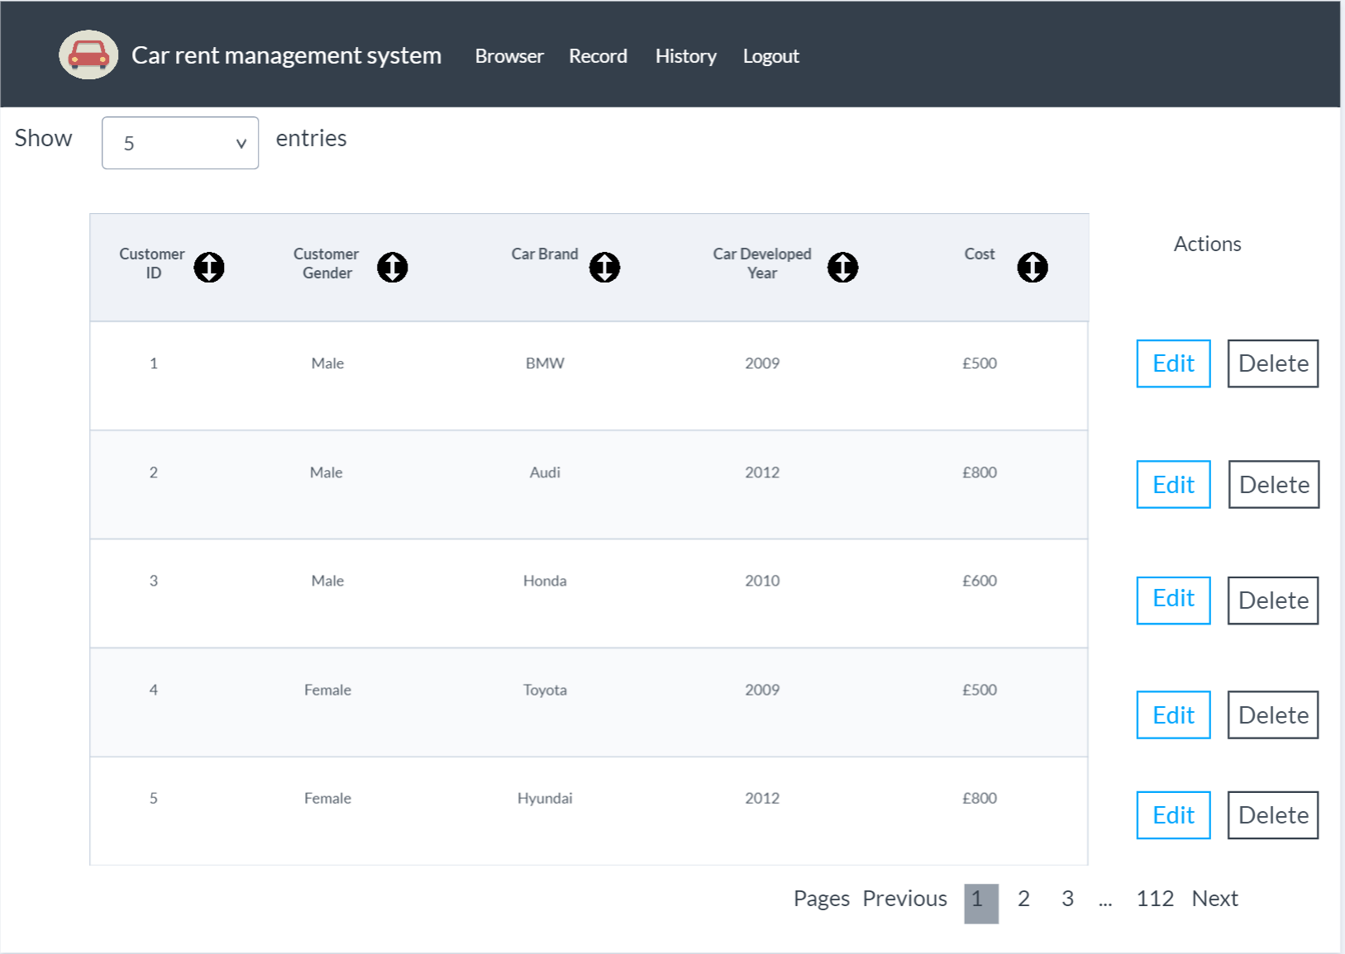

**Artefact 4** – Sign up page python coding

Description about what the artefact is in general

Python is an interpreted high-level programming language for general-purpose programming, this artefact is a 20 lines python coding which achieved sign up page functions. It enables 3 input boxes including 1 visible input box for account name and 2 invisible input boxes for password and confirm password.

Brief description of how it was used/contribution to the project

By using if else function, the sign-up page can keep running until company user meets all requirements. Firstly, the confirmed password(password2) have to be the same as password(password1), if they match, the server will check whether there’s an existing account or not, if there is no existing account then the website will go to management page which means signup successful. If account is already existed or passwords does not match, error message will pop out “Username has already been taken” or “Passwords must match”. Overall, this artefact contributes to the project by creating the sign-up page which is one of the “MUST” do priority process, its one of the basic functions that company staff needs.

Screen capture of where it’s used

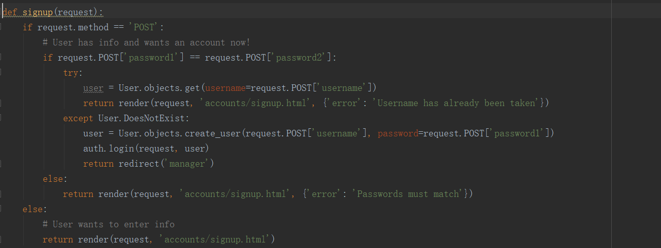

**Artefact 5** – Specific user manual

Description about what the artefact is in general

This is a specific user manual for users to guide them how to visit and access the whole website, this artefact will go into every single function that website has and explain how to access it.

Brief description of how it was used/contribution to the project

As the whole project has two entrances: one is Customer page, and another is company user page, here I am going to present the specific company staff user manual which clearly combing the process and help viewer can have a better understanding of this project from staff site.

Screen capture of where it’s used

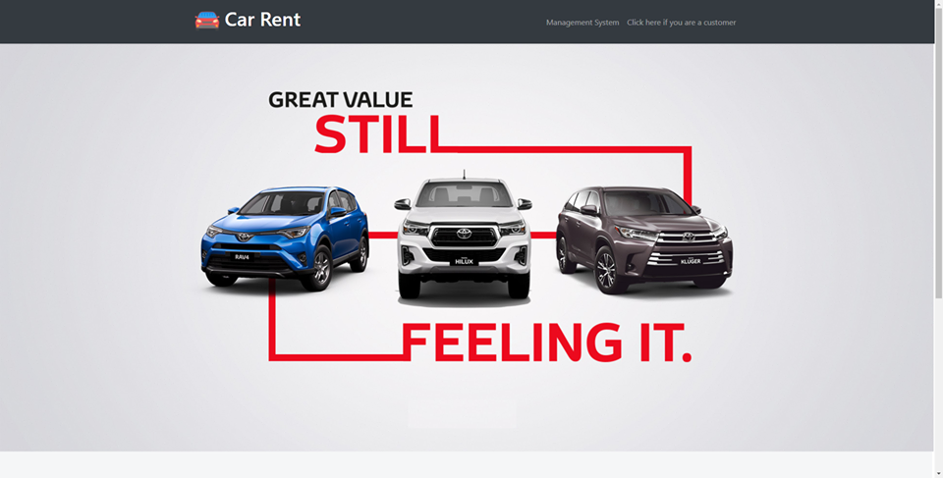

The welcome page which has two entries, one is for company staff and the other one is for customer. After clicking “management system”, the server will jump to login page

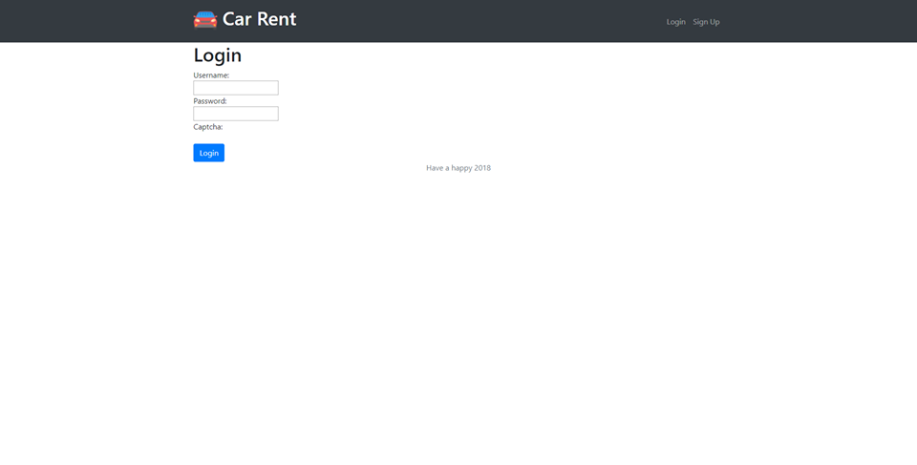

Is viewer already having a account, he can login directly, if does not, he have to sign up for the first time by clicking “sign up” hyperlink on the top right. After accessing into the management system, particularly browser page, there will be searching and sorting functions.

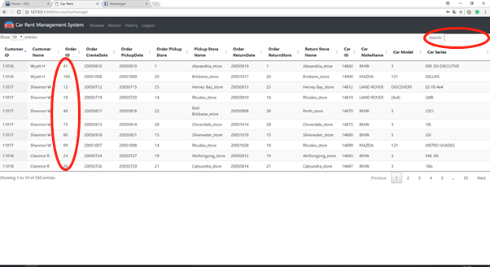

After sorted:

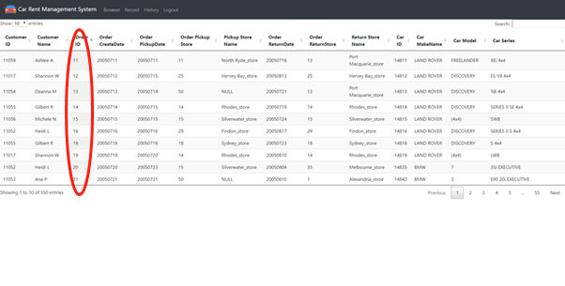

Go to Record page, we have three functions which are load new data, edit data and delete data.

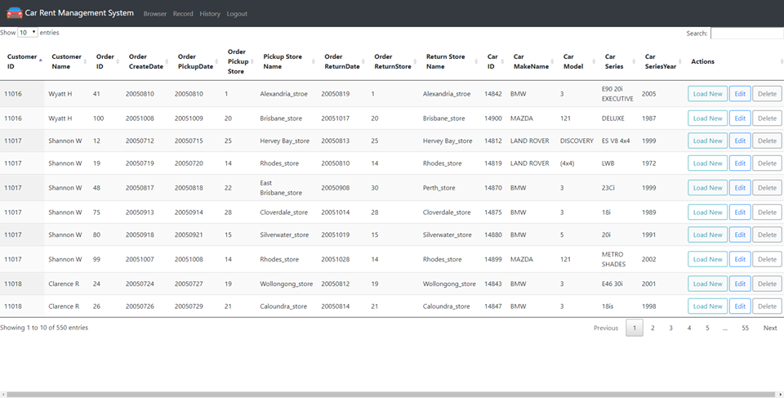

Load new data and editing page:

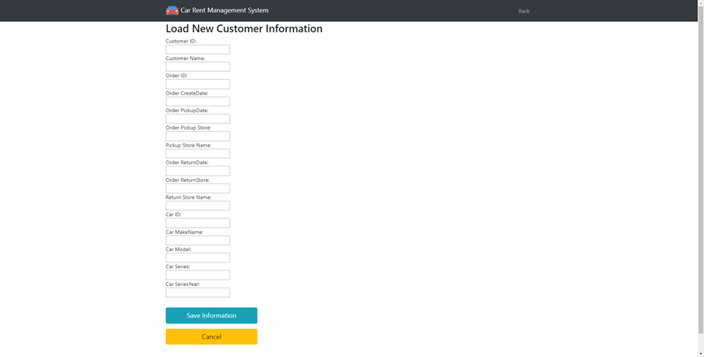

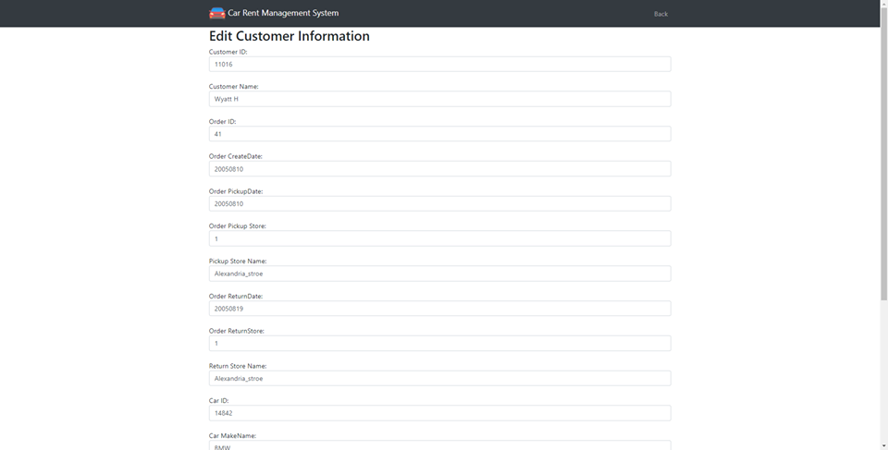

History menu can show all a happened order detail like below:

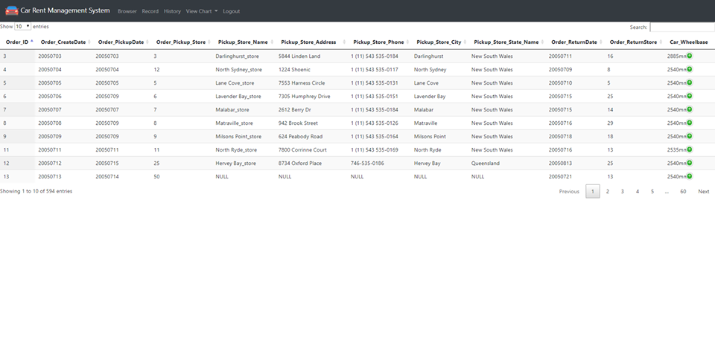

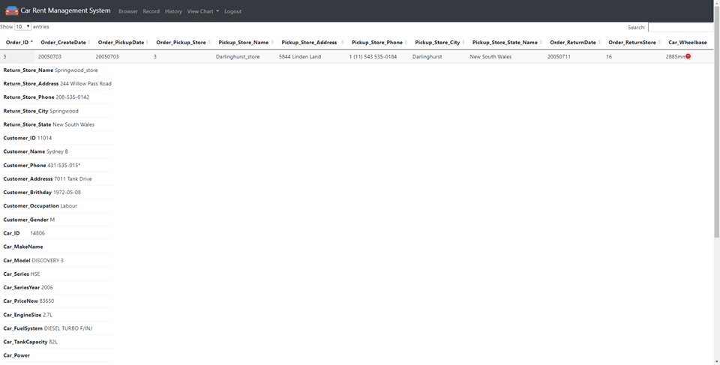

View charts can show company staff a clear pie chart and bar chart which helps them have a brief though on renting status. 